**Brooklyn torah gazette**

**For parshas bechukosai 5782**

Volume 6, Issue 34 (Whole Number 289) 27 Iyar/ May 28, 2022

**Cancel Culture Targets Civil Rights And Biblical Values Activist**

**By Steven Kovac**

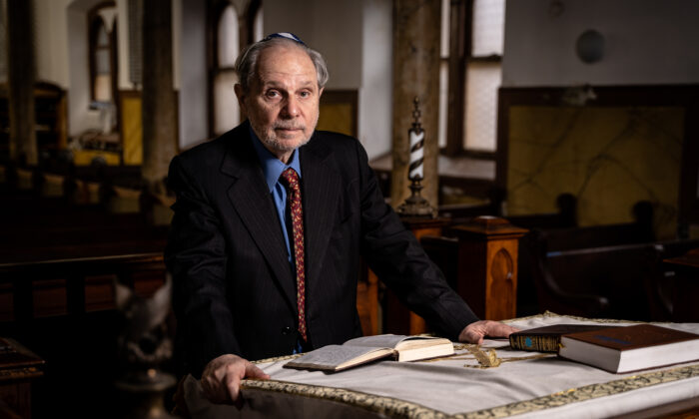

*Arthur Goldberg at Congregation Mount Sinai in Jersey City, N.J., on March 24, 2022. (Samira Bouaou/The Epoch Times)*

Now, at the age of 81, Goldberg, a devout Orthodox Jew and president of his local synagogue, is engaged in the moral and legal fight of his life.

His offense: insisting that Jewish men and others have the right to obtain counseling and therapy to overcome unwanted same-sex attraction (SSA) and founding a nonprofit organization to refer them to places of help.

“For promoting those rights, providing seekers with that information, and referring them for gender affirmation therapy, I have been canceled,” Goldberg told The Epoch Times.

“Where is the person’s right to determine his or her own therapeutic goals? Where is the freedom to choose? What happened to a person’s right to voluntarily choose to change his or her sexual orientation?

**A Devout Orthodox Jew Engaged in the**

**Moral and Legal Fight of His Life**

Now, at the age of 81, Goldberg, a devout Orthodox Jew and president of his local synagogue, is engaged in the moral and legal fight of his life.

His offense: insisting that Jewish men and others have the right to obtain counseling and therapy to overcome unwanted same-sex attraction (SSA) and founding a nonprofit organization to refer them to places of help.

“For promoting those rights, providing seekers with that information, and referring them for gender affirmation therapy, I have been canceled,” Goldberg told The Epoch Times.

“Where is the person’s right to determine his or her own therapeutic goals? Where is the freedom to choose? What happened to a person’s right to voluntarily choose to change his or her sexual orientation?

“Men and women desiring help with SSA are being denied the right to information about the availability and effectiveness of gender-affirming methods and therapies.”

According to Goldberg, gender affirmation therapy is the empowerment of willing individuals combating unwanted same-sex attraction to affirm the gender of their birth.

**Moved to Co-found JONAH to Offer Hope and Assistance**

When Goldberg, a retired investment banker, saw the painful struggles of some acquaintances dealing with SSA, he was moved to co-found a nonprofit organization called Jews Offering New Alternatives for Healing (JONAH) to offer them hope and assistance.

JONAH’s mission was to refer primarily Jewish men struggling with SSA to professional and religious counseling.

The goal was to help them fulfill their desire to live a life consistent with the tenets of their Jewish religion as declared in the Torah (the five books of Moses), which holds to heterosexuality, the marriage of a man to a woman, and the bringing forth of children within its confines.

“I saw many Jewish men, as well as people of other faiths, who wanted to be free from same-sex attraction and who desperately wanted to start a traditional family,” he said.

“They needed to know that there is available to them a guided process involving professional counseling, self-discovery, and a combination of spiritual and behavioral self-adjustments characteristic of the Jewish concept of teshuvah, meaning ‘returning to the path,’ or repentance.

“We are not about curtailing the hard-won civil rights of gay people. In fact, we acknowledge what the gay rights movement has done to improve the social status and the economic and political integration for both male and female homosexuals.

“The counseling and therapy we recommend are based on love. We only deal with people who come to us wanting to change.”

**Deep Religious Convictions and Compassion**

While Goldberg is a published author of a book and many articles on homosexuality and has much to say about the debate over its clinical and political aspects, he’s especially passionate about the spiritual side of the subject.

He views with joy and optimism the Creator’s stark declaration in the Bible’s Book of Leviticus, chapter 18, verse 22, which reads, “Thou shalt not lie with mankind, as with womankind: it is abomination.” (King James Bible)

Goldberg points out that to’eivah, the Hebrew word for “abomination,” is referring to the action and not the person—the sin and not the sinner.

Citing the teaching of several prominent rabbis and linguists, Goldberg believes that to’eivah has in it more than the idea of abhorrence, which is the common English definition.

“The Hebrew word has in its meaning the idea of ‘a straying or to be led astray.’

“To’eivah contains in it the possibility of teshuvah.

“If you can stray off the path, it is implied you can return to the path,” he said. “This offers so much hope, humaneness, compassion, and relief for those crushed between unwanted powerful personal inclinations and their strong dedication to their religion.

“The Torah teaches us that the Creator is not cruel. He is just and loving, much more willing to demonstrate mercy than to punish or destroy.

“Primarily in the West, nations have lost their traditional bearings. This has resulted in an unprecedented confusion of values.

“Once we threw away the compass of right and wrong passed down to us from ancient wisdom, self-indulgence has become the rule, supported by a good deal of creative rationalization.

“We live in a time of moral relativism, which has led to an intolerance of objective morality and those standing for it.”

Goldberg says his activism on behalf of those voluntarily seeking help with SSA, or other forms of what he calls “sexual brokenness,” is for him a religious and moral imperative.

“If a Jewish homosexual turns to another Jew for help in finding a way out of his homosexuality, the Torah indisputably forbids turning him or her away,” Goldberg said.

“A person struggling with unwanted same-sex attraction is told by the gay activist, ‘You can’t change.’ He is told by the ultra-conservative, ‘You are loathsome.’ He is told by psychiatrists and psychologists, ‘Accept your gay feelings and act upon them—even though they might conflict with your internal values.’

“In my opinion, such attitudes are immoral and irresponsible when there is help available for those desiring it. But the [cancel culture](https://www.theepochtimes.com/t-cancel-culture) is keeping people from knowing about that help and is suppressing their right to treatment.”

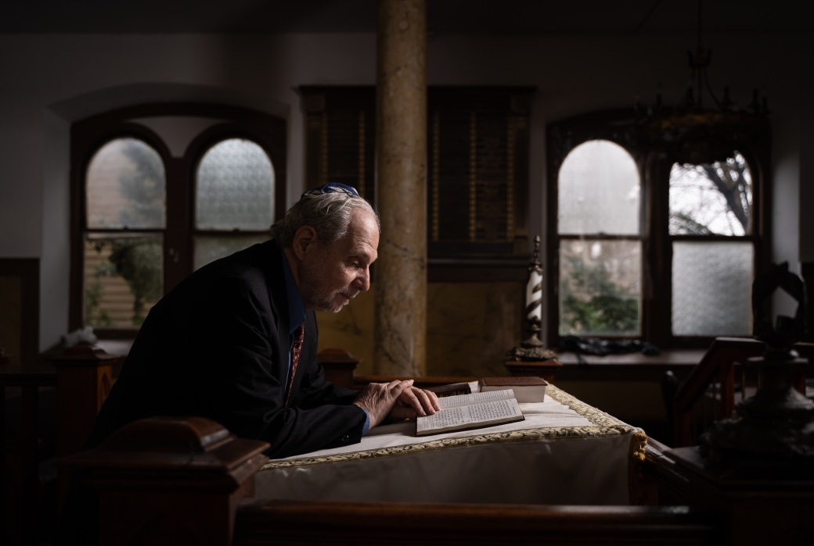

*Arthur Goldberg reads a prayer book at Congregation Mount Sinai in Jersey City, N.J., on March 24, 2022. (Samira Bouaou/The Epoch Times)*

**The High Price of Principle**

Goldberg is paying a stiff price for standing for the teachings of the Torah and the rights of others. A series of lost court battles designed to silence him over the past decade has plunged him $3 million in debt for attorney fees, costs, and fines.

Goldberg said he has never taken a salary from the two philanthropic institutions he’s been a part of.

Mounting legal bills forced Goldberg and his ailing wife, Jane, to mortgage the Jersey City, New Jersey, home where they’ve lived for nearly 50 years.

Even the crowdfunding platform he created to help pay his legal bills was shut down by the court.

“With little prospect of a conservative like me being able to use existing crowdfunding platforms, I founded a platform called Funding Morality. They soon went after it and shut it down.

“The Cancel Culture employed a strategy of bringing legal action against me and then cutting off the purse strings in order to break me financially,” he said.

His foes were not only successful in getting the court to bar Goldberg from referring anybody to counseling and gender affirmation therapy, he has also been banned for life from participating in or serving on the board of any nonprofit organization in the state of New Jersey.

Goldberg’s latest legal setback came in February, when the Supreme Court of New Jersey refused to hear his appeal to preserve his [constitutional rights](https://www.theepochtimes.com/t-constitutional-rights) of freedom of speech, association, and to freely exercise his religion.

He said for him, an appeal to the U.S. Supreme Court at this time appears unaffordable.

**The Role of the SPLC**

Goldberg says his main adversaries over the years have been the Southern Poverty Law Center (SPLC) and what he calls the “gay lobby.”

The irony of a noted civil rights advocacy organization working to cancel a civil rights advocate isn’t lost on Goldberg, who during the 1960s traveled to the South as a Freedom Rider to fight for the civil rights of black Americans.

During the 1990s, when the Soviet Union broke up, Goldberg worked in the humanitarian effort to resettle Jews fleeing Russia in the United States.

The SPLC sued Goldberg several times in a local New Jersey court, forcing him to shut down the two nonprofit organizations he helped found to further his causes.

A 2012 case against Goldberg forced the closing of the nonprofit JONAH.

A second lawsuit, filed in 2015 by the SPLC, forced the closure of the Jewish Institute for Global Awareness (JIFGA), a nonprofit ministry that Goldberg says had a different and much broader mission than that of JONAH.

“JIFGA was founded to promote and strengthen the universal underlying morals of the Judeo–Christian worldview in the United States and around the globe.

“SPLC attorneys persuaded the judge that JIFGA was a ‘mere extension’ of JONAH, which he had previously ordered to disband,” Goldberg said.

On its website, the Atlanta-based SPLC describes itself as a “catalyst for racial justice in the South and beyond, working in partnership with communities to dismantle white supremacy, strengthen intersectional movements, and advance the human rights of all people.”

“The human rights of all people except those who want to be free from unwanted same-sex attraction and those trying to help them change,” said Goldberg, when asked about the posting.

**SPLC Website Still Celebrating its Victory Over Goldberg**

The SPLC’s website is still touting its legal victory over Goldberg.

What he calls gender affirmation therapy, the SPLC and gay activists pejoratively call “conversion” or “reparative” therapy. The SPLC on its website rejects gender affirmation therapy as “harmful, abusive, junk science worse than snake oil.”

On its website, the SPLC also praised the court for what it calls the “landmark” pre-trial ruling in which the judge “excluded several conversion therapy proponents from testifying as defense witnesses because their opinions were based on the false premise that homosexuality is a disorder.”

The website quotes the judge as saying that the theory that homosexuality is a disorder is “like the notion that the earth is flat and the sun revolves around it … outdated and refuted.”

“The exclusion of defense witnesses was unfair,” Goldberg said. “We had expert witnesses prepared to explain what gender affirmation therapy actually is and to present real case histories of its effectiveness. The judge barred them from testifying.

“The SPLC lawyers were very good at falsely describing to the court how ‘disturbing, dangerous, and harmful’ gender affirmation therapy supposedly is.

“It seems clear the judge bought into the gay lobby’s widely publicized and popularly embraced propaganda that homosexuality is an immutable characteristic a person is born with.

“The fact is, science has yet to discover a so-called ‘gay gene.'”

Goldberg said of the judge’s comments about homosexuality no longer being considered a disorder, “The declassification of homosexuality as a disorder by the American Psychiatric Association in 1973 and the American Psychological Association in 1974 was more a social and political decision than a reevaluation based on any new science.”

Political pressure from gay activists to normalize homosexuality has chilled public discourse and has had a detrimental effect not only on patient rights, but also on patient care, Goldberg said.

**Concern for Future Generations**

“To disagree with the ideology of the gay lobby is to be branded a ‘hater’ and a ‘homophobe.’ People are afraid to speak. Even many religious leaders won’t address the subject.

“Even worse, qualified professional psychologists are deciding not to offer what they know are effective gender-affirming therapies for fear of being sued by gay activist groups,” he said.

Despite the hardships of the past decade, Goldberg says he’s been blessed with a full and happy life.

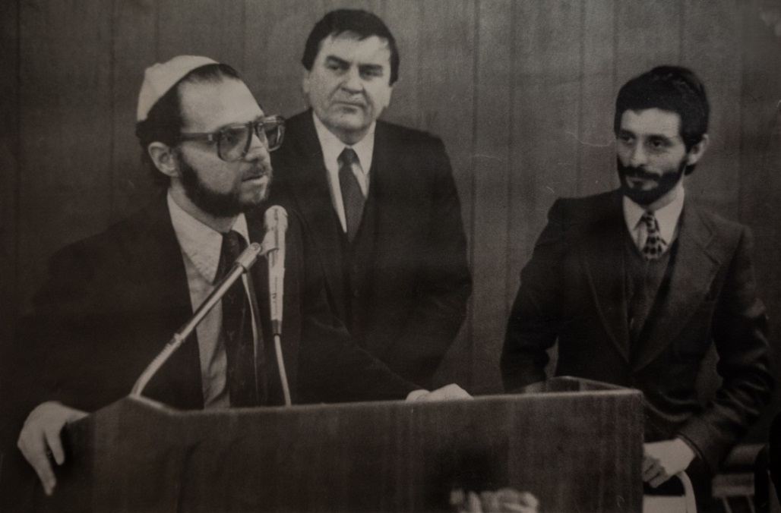

***(L-R) Then-chairman Arthur Goldberg, former Jersey City Mayor Thomas F.X. Smith, and then executive director of Committee for the Absorption of Soviet Emigrees Joseph Shneberg, in the mid-1980s. (Courtesy of Arthur Goldberg)***

Born in Jersey City, he attended local schools. He went on to earn a degree from the American University in Washington and graduated from Cornell University Law School.

“Early on, I became active in the civil rights movement because of my love for the U.S. Constitution, the Bill of Rights, and the founding principles of our republic—principles that are increasingly coming under attack from many quarters,” he said.

Goldberg has also served as a congressional aide and as a deputy attorney general in New Jersey.

“After practicing law for a few years, I went to work on Wall Street as an investment banker specializing in the financing of public purpose projects,” he said.

As an author, Goldberg is best known for his nearly 600-page book “Light in the Closet,” a scholarly yet readable study of the Torah, homosexuality, and the power to change.

**Goldberg Has Lived All His Life in Jersey City**

“I’ve lived in Jersey City all of my life,” he said. “When the city began to decay, I resolved to stay here and do what I could to prevent its further decline.

Goldberg and Jane, his wife of 53 years, have four children and six grandchildren.

He says it’s for his grandchildren and coming generations that he continues to labor to preserve the values of the United States he grew up in.

Of particular concern to him is the successful efforts of gay activists to infiltrate U.S. schools with what Goldberg calls their “anti-religion, anti-family doctrine.”

“Across America, children from preschool on up are being indoctrinated with the pro-gay, pro-trans agenda under the guise of student health, school safety, anti-bullying, diversity, and tolerance lessons.

“The programs I have studied and carefully documented in my book range from sensitization to outright recruitment. It’s all part of the effort to prematurely sexualize our children.

“Sexually explicit literature, pamphlets, and audio-visual materials are routinely presented to students without the knowledge or consent of parents.

**Special Speakers Brought into the Schools to Influence Children**

“In some schools, special speakers are brought in to graphically describe their homosexual experiences and lifestyle. This happens not just in high school but in elementary school, too.

“There are next to no lessons about the physical and psychological risks of homosexual behavior. Even sex-change counseling is being presented to students in elementary, middle, and high schools, unbeknownst to parents.

“Parents need to be interested, informed, and proactive in monitoring what their children are being exposed to in public and private schools across our nation, or soon we will not have a country that bears any resemblance to the land of liberty that was founded on and made great by Judeo–Christian principles passed down to us by our forefathers.”

Reprinted from the April 5, 2022 edition of The Epoch Times.

**How You Can Help**

**Arthur Goldberg**

See below his letter requesting financial support.

“However, given the severity of the financial penalties involved, I hope I am not being too forward in asking whether you may be able to contribute funds at this time. It is imperative that I raise a significant amount of money to meet the staggering court imposed penalties facing me. The best way is to either use a crowd-funding site [**www.lifefunder.com/therapy**](http://www.lifefunder.com/therapy) or to send a check to me at PO Box 313, Jersey City, NJ 07303. Thanks for any help you may provide.

“Thank you for being part of our movement for freedom and justice. In spite of this loss and in order to save the traditional value system we believe should be part of our culture, we must not give up!

“I am more than happy to speak with you if you have any questions. I look forward to hearing from you.”

Blessings,



Arthur Goldberg

Cell 917-929-0087

[goldberg_arthur@aol.com](https://webmailb.juno.com/webmail/new/21?folder=Inbox&msgNum=000117k0:001YW8PL000027bg&count=1652628976&randid=83019750&attachId=0&isUnDisplayableMail=yes&blockImages=0&randid=83019750)

**Rav Avigdor Miller On Why We Count Sefiras Ha’Omer**



**QUESTION: What should we think about when we count sefiras haomer?**

**ANSWER:** Now, everyone knows that we’re counting sefira to come closer to the very greatest event in history; and that event was Matan Torah. If not for Matan Torah, the whole creation would have been a waste. And so everybody knows that we were counting down towards that great day, the most important day ever.

But there is a kasha on this p’shat. Because why do we say, “Today is so and so many days” and the next day we add a day; we count up, one day, two days, three days. We should count down. Like this: “Today is 49 days of the omer, 49 days till Matan Torah.” The next day we should count 48, then 47. If you’re waiting for Matan Torah that’s how you should count.

**Understanding the Kasha**

I want to make sure the kasha is understood. You should go from the bigger number to the lesser number. And the less days there are left, the happier you are.

Also, why call it Sefiras Ha’omer? We should call it Sefiras Hatorah. Why Sefiras Ha’omer? What does it have to do with the omer?

So pay attention. There is a machlokes ha’poskim if the brocha we make on talmud torah is mi’dioraisah, if it’s a torah obligation. We follow the shitah that it’s mi’dioraisah. It means that if you’re in a safek if you made a brocha on the Torah in the morning, you have to say it anyhow, even though you might have said it already. In case you want, you can wait till Ahavah Rabah, the bracha before krias shema and be michaven that you’re thinking of bircas hatorah; but you must do something. But even though that’s the halacha, there are poskim who say that birchas hatorah is de’rabanan. It’s a machlokes haposkim.

And yet, when it comes to the bracha on eating bread, everyone agrees it’s d’oraisah.  Isn’t that an interesting thing? The bracha on Torah is a machlokes but the bracha after eating bread, hakol modim is d’oiraisah; everybody agrees that the possuk ארץ אשר לא במסכנות תאכל בה לחם … ואכלת ושבעת וברכת means you have to say brachos after eating bread.

**Bread is More Important than Torah?**

So what do we see from this? That bread is more important than Torah; bread is more important than Torah because bread is life and life is the most important thing. Without that we couldn’t learn Torah. Not merely you say im ein kemach ein torah. No; kipshuto, bread is the opportunity to live in this world.

So what do we do? We thank Hakodosh Boruch Hu for the bread and everyday we count. “Today is the first day we’re thanking You for the bread.” “Today is the second day we’re thanking You for the bread.” The omer means bread. The third day, the fourth day. Keep on thanking.

Now where does it all end up? At Matan Torah. The bread is for the purpose of kabolas hatorah, for learning Torah. We’re thanking Hashem for giving us life. Boruch Hashem that You give us food to live.

**A Mitzvah to Eat Bread Every Morning**

So when you sit down to eat bread in the morning – every morning you eat a piece of bread, pas shacharis. The Gemara says it’s a mitzvah to eat bread every morning, a little piece of bread, and it will save you from many illnesses, many sicknesses. When you eat that piece of bread, so you’re thinking, “Ahh! Bread! That’s Torah, that’s life, that’s everything.” And when you say ברוך אתה השם … המוציא לחם מן הארץ, say it with hisragshus, with excitement. Love Hashem for the bread because bread is going to bring you to everything else.

And that’s what sefira is coming to tell us. How great is the gift that Hashem gives us! פותח את ידיך ומשביע לכל חי רצון. He’s feeding us! And the purpose is eventually, to bring us to Har Sinai, to Matan Torah. It gives us life, and with all of that happiness and gratitude that we’re increasing every day, that’s how we go into Matan Torah. We love You so much Hashem for the bread You give us, that now we’re going to accept the Torah.

*Reprinted from May 16, 2022 email of Toras Avigdor. Adapted from Tape # E-8.*

**The Task of a Jew to Engrave**

**The Torah into His Heart**

**From the Talks of the Lubavitcher Rebbe**

**Rabbi Menachem Mendel Schneerson, Zt”l**

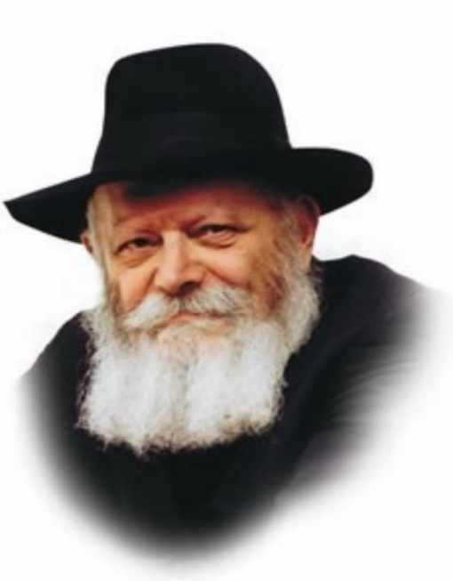

The opening verse of this week's Torah portion, Bechukotai, "If you will walk in my statutes," is explained to mean that a Jew must labor hard in his study of Torah.

A question is asked: Why does the Torah connect the commandment to study Torah diligently with G-d's statutes? The answer is found when we take a closer look at the Hebrew word for "statutes" itself.

The phrase "In my statutes," "Bechukotai," comes from the Hebrew word meaning "to engrave."

There are two ways in which letters may be written. One way is with ink applied to parchment (or any other material); another way is to inscribe them in stone. When letters are written, the ink and the parchment remain two separate entities, even though the act of writing unites them, to a certain degree, on the same page. Nonetheless, the letters do not become part and parcel of the material on which they are written.

When letters are carved into stone, by contrast, the letters and the stone are inseparable. Each letter comes into being at the exact moment it is inscribed and can never be erased or obliterated.

The Torah commands us to learn Torah in a manner of "inscription."

A Jew who studies Torah must be so connected to what he is learning that he and Torah unite and form a single entity, just like an engraved letter does not exist prior to its inscription and can never be erased. We must learn Torah so diligently that its holy words become permanently chiseled into our souls.

The Chasidic work, Likutei Torah, explains that the literal translation of "Im bechukotai teileichu" is "If in My statutes you will walk." When a Jew studies Torah in a manner of "engraving," he merits a reward -- that he "will walk." G-d promises that if we truly apply ourselves to learning Torah we will never be immobile and stationary, but will progress and ascend ever upward, perpetually increasing our understanding and connection to G-d. A Jew whose soul is united with the Torah is thus ensured that he will always rise up the ladder of spiritual achievement.

Reprinted from the Parshas Bechukosai 5757/1997 email of L’Chaim Weekly. *Adapted from Likutei Sichot, Vol. 3*

**Rabbi Berel Wein on**

**Parshat Bechukosai 5782**

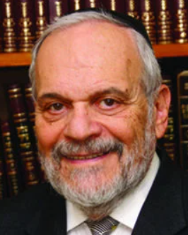

This week's Torah reading marks the end of the book of Vayikra. This, the third book of the Torah, is replete with laws, commandments, and descriptions of Temple services. It is also the book that contains the fundamental principles of human relationships, as envisioned by the Torah and Jewish tradition. It is a book about holiness, but not only about ritual holiness or Temple service, but also the holiness of human beings and human relationships.

The great principle of the Torah is included in this book – to be able to love and treat another human being as one can love oneself and wish to be treated by other human beings. It is this balance between ritual practice and exalted social and psychological values that in many ways characterize the essence of Judaism and of traditional Jewish life. By combining these two facets of the commandments granted to us on Mount Sinai, Judaism asserts its eternity, its service to our Creator and to the human beings that he created.

Though we often divide the commandments that appear in this book into two separate sections – those that relate to G-d and those that relate to our fellow human beings – in reality it is only in the totality of two taken together that one can see and experience the true nature of Judaism and Jewish life. Since both sections are equally commanded, so to speak, by the total, they are not to be viewed as two distinct sections of Jewish life, but, rather, as the two components that create the totality of Jewish life and our eternal existence.

With the exception of the story of the tragedy of the sons of Aaron, the entire book of Vayikra is free of narratives. This is unique, for the other four books of the Chumash contain a great deal of narrative. The commentators note this exception, and state that one of the reasons for this is to emphasize to all later Jewish generations that even though the narrative story of the Jews and of Judaism is vitally important, that story can never be communicated in a meaningful and eternal fashion, without the observance and study of the laws and commandments that form such a basic part of Jewish life.

The future of the Jewish world is determined by loyalty to tradition and observance of commandments. As important as knowledge of history is – and I consider it to be very important – history alone can never preserve us. There are many great schools in the world that teach and delv into the history of past civilizations and great empires. The studies may be fascinating and increase our sense of scholarship, but they do nothing to revive those civilizations and empires that have passed from the scene, never to return.

It is only through the actual enactment and discipline of commandments on a daily basis that we can be confident that the narrative of the Jewish people will continue and grow. It is in this knowledge that we are strengthened by this moment of completion of this holy book of the Chumash Vayikra.

*Reprinted from the current website of rabbiwein.com*